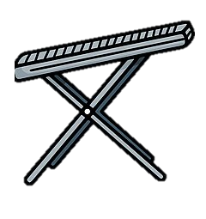
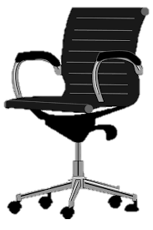
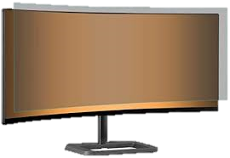

provide foot supports
provide adjustable chairs
provide anti-glare screen filters
Provide Tiltable Screens
EMPLOYER REGULATIONS

